FotoPhrase: An AI-Based Image Caption Generator With Voice Assistance Using Machine Learning
KUNCHALA SWATHI¹, KANUSU SURYA KUMAR², MADUGULA SAILAJA³, KARANAM ANVESH^{4,} NALLURI SRIKANTH
¹Student, Department of CSE, Bapatla Engineering College, Bapatla 522101, AP, India
²Student, Department of CSE, Bapatla Engineering College, Bapatla 522101, AP, India
³Student, Department of CSE, Bapatla Engineering College, Bapatla 522101, AP, India
⁴Student, Department of CSE, Bapatla Engineering College, Bapatla 522101, AP, India
⁵Assistant Professor, Department of CSE, Bapatla Engineering College, Bapatla 522101, AP, India
Corresponding author. Email: swathikunchala888@gmail.com

ABSTRACT
Automatic image caption generation is a challenging task that integrates computer vision and natural language processing to produce meaningful textual descriptions for images. This paper presents FotoPhrase, an assistive artificial intelligence system designed to generate captions using deep learning techniques trained on the Flickr30k dataset. The proposed system follows an encoder–decoder architecture to extract visual features and convert them into coherent natural language descriptions. It provides a user-friendly interface supporting both image upload and real-time camera input, along with text-to-speech functionality to enhance accessibility for visually impaired users. Experimental results demonstrate that the system can generate contextually relevant captions for common scenes, although performance may vary in complex scenarios or with visually similar objects. The proposed approach highlights the potential of image captioning systems in assistive technologies, content understanding, and human-computer interaction. Furthermore, the system emphasizes real-time usability and interactive design, making it suitable for practical deployment.
KEYWORDS-Image Captioning, Deep Learning, Flickr30k, Computer Vision, Natural Language Processing, Assistive Technology
- INTRODUCTION
With the rapid growth of digital images, there is an increasing demand for systems that can automatically understand and describe visual content. Image captioning is a challenging task that combines computer vision and natural language processing to generate meaningful textual descriptions for images. In this paper, we propose FotoPhrase, an assistive AI-based system that generates captions using deep learning techniques trained on the Flickr30k dataset. The system integrates a user-friendly interface with support for image upload, real-time camera input, and text-to-speech functionality to enhance accessibility, especially for visually impaired users. The proposed approach demonstrates the potential of image captioning in real-world applications such as assistive technologies and content understanding, while highlighting challenges in handling complex scenes and similar objects.
- LITERATURE SURVEY
Image captioning is a challenging problem that integrates Computer Vision and Natural Language Processing to automatically generate textual descriptions for images. Earlier approaches relied on template-based and retrieval-based methods, which lacked flexibility and were unable to generalize well to unseen data [1]. These traditional methods also suffered from the semantic gap between visual features and language understanding.
With the emergence of Deep Learning, significant improvements have been achieved in caption generation tasks. Modern approaches use encoder–decoder architectures, where Convolutional Neural Networks (CNNs) are used for extracting visual features and Recurrent Neural Networks (RNNs), particularly Long Short-Term Memory (LSTM) networks, are used for generating captions sequentially [3]. This combination enables models to learn both spatial and contextual relationships effectively.
Several studies have demonstrated that CNN-LSTM based architectures can generate coherent and context-aware captions. CNN models such as VGG16 and ResNet extract meaningful image features, while LSTM networks handle sequence prediction and sentence formation [4]. These models are commonly evaluated using performance metrics such as BLEU score, which measures the similarity between generated and reference captions.
Further advancements include the use of attention mechanisms, which allow the model to focus on important regions of an image while generating each word. This improves the accuracy and relevance of generated captions compared to traditional encoder–decoder models [2]. Attention-based models mimic human visual perception and produce more descriptive outputs.
Research has also explored hybrid and improved architectures for better performance. Some approaches integrate object detection techniques with caption generation models to capture detailed information about multiple objects in an image [6]. Additionally, various deep learning frameworks and implementations have been proposed to simplify the development of captioning systems using Python and libraries such as TensorFlow and Keras [5].
Datasets play a crucial role in training image captioning models. Common datasets include Flickr8k and Flickr30k, which provide images with multiple human-annotated captions. Among these, Flickr30k offers a larger dataset with more diverse captions, leading to better generalization and improved model performance [4].
Despite these advancements, challenges such as handling complex scenes, generating diverse captions, and computational efficiency still remain. Many models struggle with fine-grained object recognition and contextual ambiguity in real-world scenarios.
In this work, the proposed FotoPhrase system builds upon these existing approaches by leveraging deep learning techniques trained on the Flickr30k dataset. The system integrates image captioning with a user-friendly interface and voice assistance, making it suitable for assistive applications and real-time usage [7].
- TECHNOLOGY USED
- Python
Python is a high-level, interpreted programming language widely used in machine learning and artificial intelligence applications. It provides simple syntax, readability, and extensive library support, making it suitable for developing image captioning systems. Python supports multiple programming paradigms, including object-oriented and functional programming, and is highly efficient for rapid prototyping and development.
- PyTorch
PyTorch is an open-source deep learning framework used for building and training neural networks. It provides dynamic computation graphs and GPU acceleration, enabling efficient model training and inference. In this project, PyTorch is used to implement and run the image captioning model trained on the Flickr30k dataset.
- Flickr30k Dataset
The Flickr30k dataset is a widely used benchmark dataset for image captioning tasks. It contains approximately 31,000 images, each annotated with five human-generated captions. This dataset helps the model learn the relationship between visual features and natural language descriptions, improving caption quality and generalization.
- Convolutional Neural Networks (CNN)
CNNs are used for extracting visual features from input images. They identify patterns such as edges, textures, and objects, converting images into feature vectors that can be processed by language models.
- Long Short-Term Memory (LSTM)
LSTM is a type of Recurrent Neural Network designed to handle sequential data and long-term dependencies. It is used in this project to generate captions word by word based on extracted image features.
- CustomTkinter
CustomTkinter is a modern UI framework built on top of Tkinter. It is used to design an interactive graphical user interface for the system, allowing users to upload images, access the camera, and view generated captions in a visually appealing environment.
- OpenCV
OpenCV (Open Source Computer Vision Library) is used for real-time image processing and camera integration. It enables capturing images from a webcam and converting them into a format suitable for model input.

- PIL(Python Imaging Library)
PIL is used for image preprocessing tasks such as resizing, format conversion, and enhancement. It ensures that images are properly prepared before being fed into the model.
- pyttsx3 (Text-to-Speech Engine)
pyttsx3 is an offline text-to-speech library used to convert generated captions into spoken audio. This enhances accessibility, especially for visually impaired users.
- Threading
Threading is used to execute multiple tasks simultaneously, such as running the AI model and handling the user interface. This ensures that the application remains responsive during image processing.

- PROPOSED SYSTEM
The overall workflow of the proposed system can be divided into the following main steps:
1. Read Captions File:
The system reads the Flickr30k captions file, which contains multiple descriptions for each image. The captions are parsed, tokenized, and mapped to their respective image IDs.
2. Data Cleaning:
The captions are cleaned by converting text to lowercase, removing punctuation, numbers, and unnecessary characters. This improves the quality of training data and ensures better model performance.
3. Loading Training and Testing Data:
The dataset is divided into training and testing sets. A caption dictionary is created where each image is associated with multiple captions, including special tokens such as <start> and <end> to define sentence boundaries.
4. Data Preprocessing – Images:
All images are loaded and resized to a fixed dimension. Feature extraction is performed using a Convolutional Neural Network (CNN), converting images into numerical feature vectors.
5. Data Preprocessing – Captions:
Captions are tokenized and converted into sequences of integers using a vocabulary index. Padding is applied to ensure all captions have equal length.
6. Data Preparation using Generator:
A data generator is used to efficiently feed images and corresponding captions into the model during training. This helps in handling large datasets like Flickr30k without memory issues.
7. Word Embedding:
Words are converted into dense vector representations using an embedding layer. This helps the model understand semantic relationships between words.
8. Model Architecture:
The system uses a CNN-LSTM architecture:
- CNN acts as an image feature extractor
- LSTM generates captions based on extracted features
Both networks are combined to form a unified model for caption generation.
9. Train the Model:
The model is trained using the prepared dataset over multiple epochs. During training, the model learns to map image features to corresponding textual descriptions.
10. Predictions:
After training, the model generates captions for new images. The system predicts words sequentially until the end token is reached, forming a complete sentence.
- PROPOSED SYSTEM
- Read Captions File
- Data Cleaning
- Loading Training and Testing Data
- Data Preprocessing – Images
- Data Preprocessing – Captions
- Data Preparation Using Generation
- Word Embedding
- Model Architecture
- Train the Model
- Predictions

- ANALYSIS
The iterative development model aims to develop the system by building and refining features in multiple cycles. In this project, the model is used to gradually improve the performance of the image caption generator by training, testing, and optimizing the system in repeated iterations. Each iteration enhances the accuracy of caption generation and improves the user interface for better interaction.
The phases of iterative development are:
- Planning:
In this phase, the project requirements are defined, including dataset selection (Flickr30k), model architecture, and system functionalities such as image upload, camera integration, and voice output. Hardware and software requirements are also identified.
- Analysis:
The feasibility of the system is analyzed by studying existing image captioning techniques and selecting suitable approaches such as CNN-LSTM or transformer-based models. The dataset structure and preprocessing requirements are also examined.
- Design:
In this phase, the system architecture is designed, including the image feature extraction module, caption generation module, and user interface. Flowcharts, data flow diagrams, and model structures are prepared.
- Implementation:
The actual coding of the system is carried out using Python. The model is trained on the Flickr30k dataset, and the GUI application is developed using libraries like CustomTkinter, OpenCV, and PyTorch.
- Testing:
The system is tested using different images to evaluate caption accuracy and performance. Errors and inconsistencies are identified and corrected in each iteration.
- Evaluation:
The performance of the model is evaluated using metrics such as BLEU score and qualitative analysis of generated captions. Improvements are made based on the results.
- Deployment:
Finally, the system is deployed as a desktop application that allows users to upload images or use a camera for real-time caption generation with voice assistance.

- FEASIBLITY STUDY

Image captioning systems mainly depend on large and diverse datasets to perform effectively. The quality of captions improves when the model is trained on datasets like Flickr30k, which contain a wide range of images and meaningful descriptions. Modern approaches use deep learning techniques such as CNN-LSTM or transformer-based models to understand images and generate natural language captions.
- Product/Service Marketplace:
The proposed system can be useful in many real-world applications. It helps users automatically generate captions for images, which can improve user experience on social media platforms, assist visually impaired individuals, and support image-based content management systems.
- Tools:
The system is developed using widely used tools such as Python, along with libraries like PyTorch for model building and OpenCV for image processing. Training can also be done using platforms like Google Colab, which provide free GPU support and reduce the need for high-end hardware.
- Processes:
By automating caption generation, the system reduces manual effort and simplifies tasks such as image description and indexing. This leads to faster and more efficient workflows in various applications.
- Hardware/Software:
The system can run on standard computers, although GPU support can significantly improve performance during training. It can be applied in areas like accessibility tools, social media, and other applications involving image understanding and natural language processing.
- Operational Feasibility:
The system is designed to be simple and user-friendly, making it easy for users to interact with it. Its modular structure ensures smooth functioning and allows future improvements or extensions without major changes.

- COST ANALYSIS
The cost of developing and implementing the proposed image captioning system is relatively low, as it primarily relies on open-source tools and publicly available datasets. The major expenses are associated with computational resources required for training the deep learning model.
Infrastructure Costs:
The system can be deployed using cloud platforms such as Google Colab, Amazon Web Services (AWS), or Microsoft Azure. These platforms provide GPU support for faster training. The approximate cost for cloud usage is around $0.4 to $3 per hour depending on the type of GPU used. However, for academic purposes, free tiers like Google Colab are sufficient, which significantly reduces the overall cost.
Hardware Costs:
The model can also be trained on a local system with moderate specifications. A system with an Intel i5/i7 processor, 8–16 GB RAM, and an optional GPU (such as NVIDIA GTX series) is sufficient. Since most students already have access to such systems, no additional hardware investment is required.
Software Costs:
All software tools used in this project, including Python, PyTorch, OpenCV, and CustomTkinter, are open-source and freely available. This eliminates the need for licensing costs.
Training Cost:
Training the model on the Flickr30k dataset requires computational time, especially when training from scratch. However, by using pre-trained models or limited epochs, the training cost can be minimized. Using free cloud GPUs further reduces expenses.
Overall cost Evaluation:
Considering the use of free tools, publicly available datasets, and optional cloud resources, the overall cost of the system is minimal. This makes the project economically feasible for students and small-scale applications while still delivering effective performance.

- DESIGN
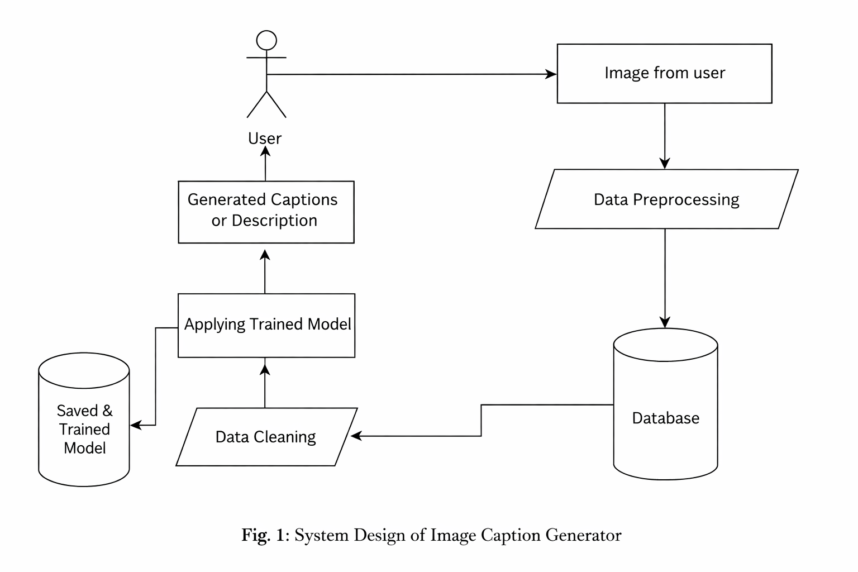

- RESULT DEMO
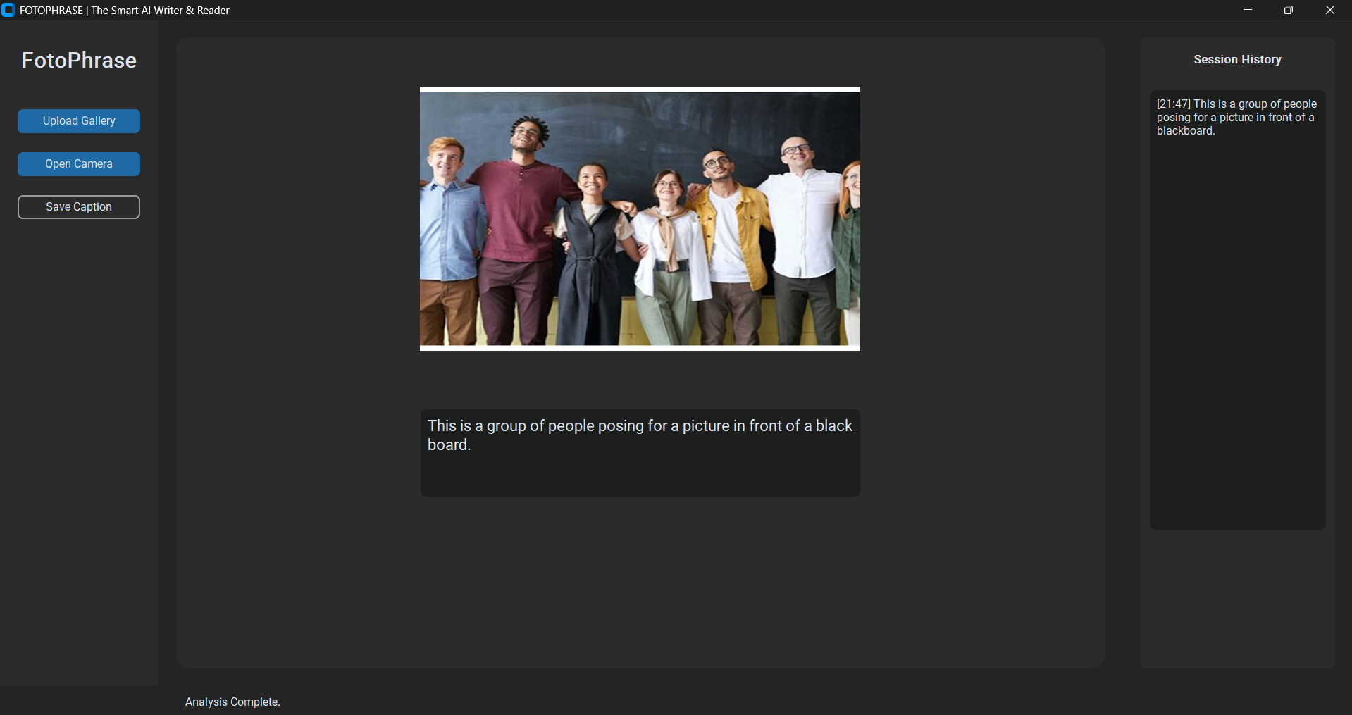
- CONCLUSION
This paper presents FotoPhrase, an intelligent image captioning system that generates meaningful descriptions using deep learning techniques trained on the Flickr30k dataset. The system integrates computer vision and natural language processing to convert visual features into coherent text, with support for image upload, real-time camera input, text-to-speech, and caption saving. It demonstrates effective performance and can be applied in assistive technologies, social media, and image indexing.
- RFERENCES
[1] P. Kotak and P. Kotak, “Image Caption Generator,” International Journal of Engineering Research & Technology (IJERT), vol. 10, no. 11, Nov. 2021.
[2] “A Guide to Image Captioning,” Towards Data Science. [Online]. Available: https://towardsdatascience.com/a-guide-to-image-captioning-e9fd5517f350
[3] “Image Captioning using Deep Learning,” IEEE Xplore. [Online]. Available: https://ieeexplore.ieee.org/document/8276124
[4] J. Brownlee, “Develop a Deep Learning Caption Generation Model in Python,” Machine Learning Mastery. [Online]. Available: https://machinelearningmastery.com/develop-a-deep-learning-caption-generation-model-in-python/
[5] R. Shinde, “Image Captioning with Flickr8k Dataset (BLEU),” Medium. [Online]. Available: https://medium.com/@raman.shinde15/image-captioning-with-flickr8k-dataset-bleu-4bcba0b52926
[6] “Image Caption Generator,” Clairvoyant Blog. [Online]. Available: https://blog.clairvoyantsoft.com/image-caption-generator-535b8e9a66ac
[7] “Image Captioning System,” MATEC Web of Conferences. [Online]. Available: https://www.matec-conferences.org/articles/matecconf/abs/2018/91/matecconf_eitce2018_01052/matecconf_eitce2018_01052.html
[8] “Solving an Image Captioning Task using Deep Learning,” Analytics Vidhya. [Online]. Available: https://www.analyticsvidhya.com/blog/2018/04/solving-an-image-captioning-task-using-deep-learning/

